DFD Diagrams:
Context Level (0th Level Diagram)
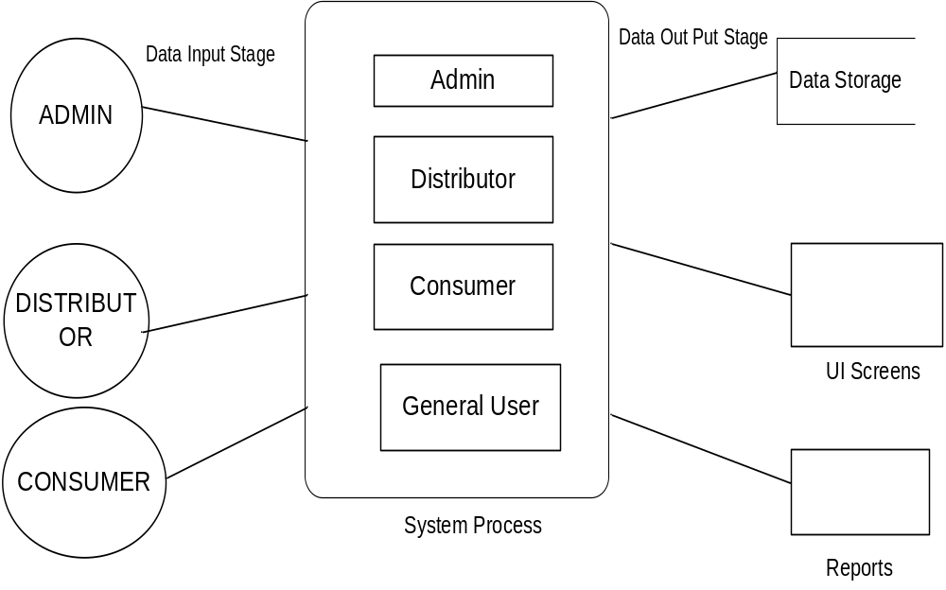
Login DFD Diagram:
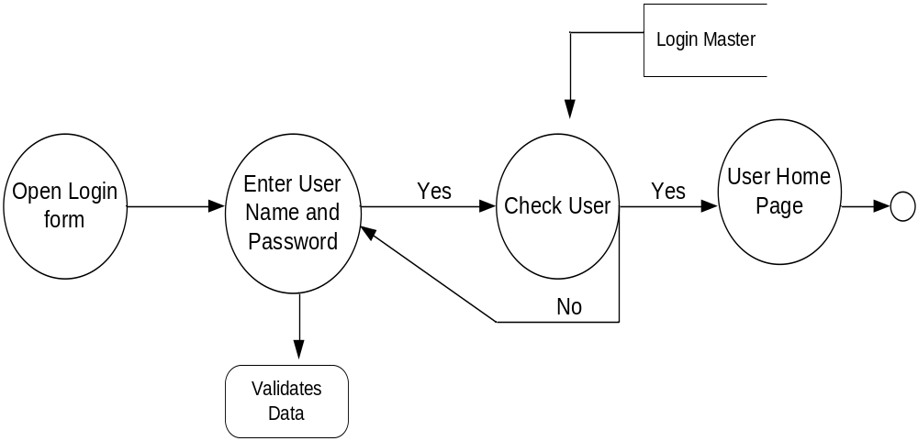
Admin Details Data Flow
1st Level DFD
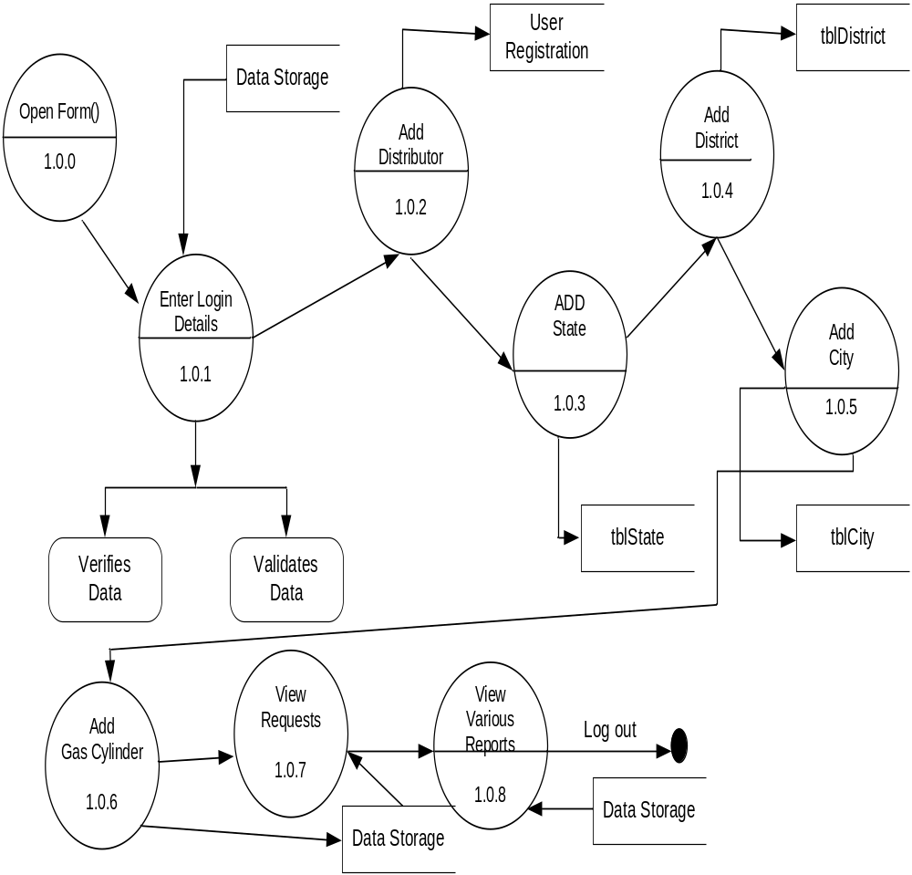

Distributor Details Dataflow Diagram:
1st Level DFD diagram:
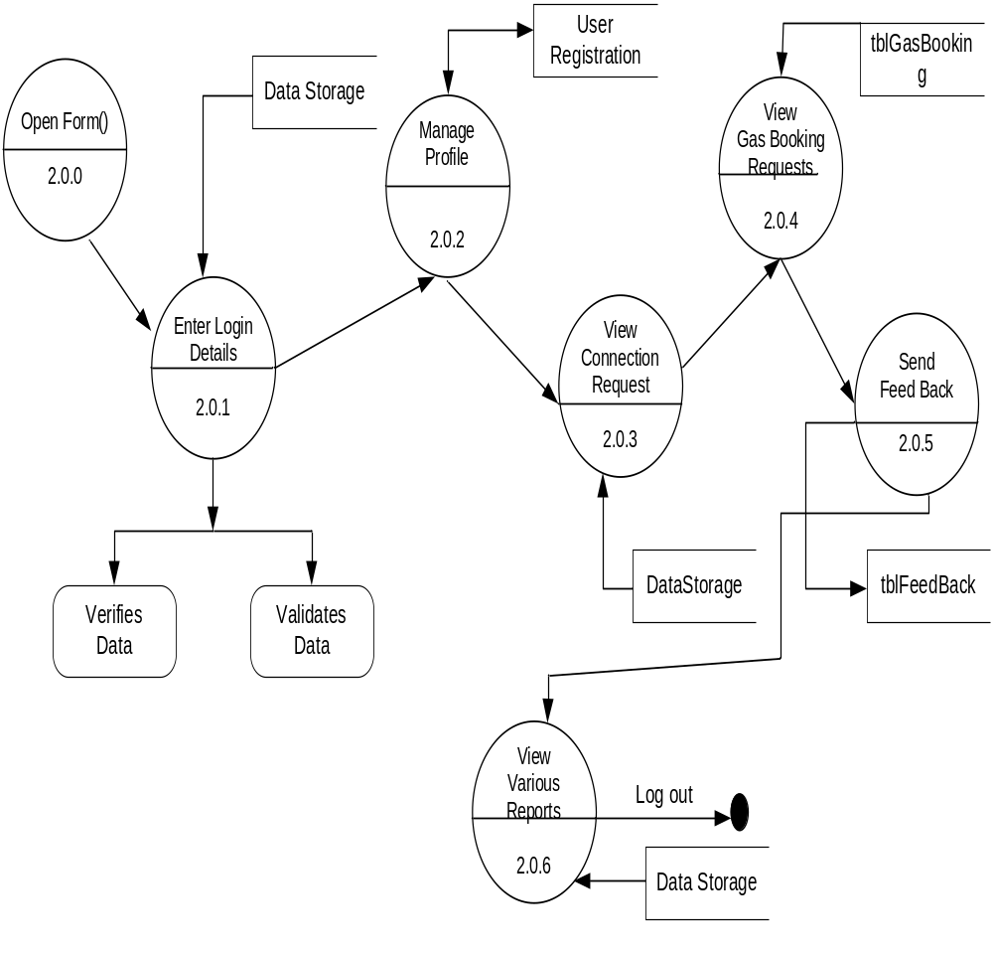

Consumer Details Data Flow Diagram:
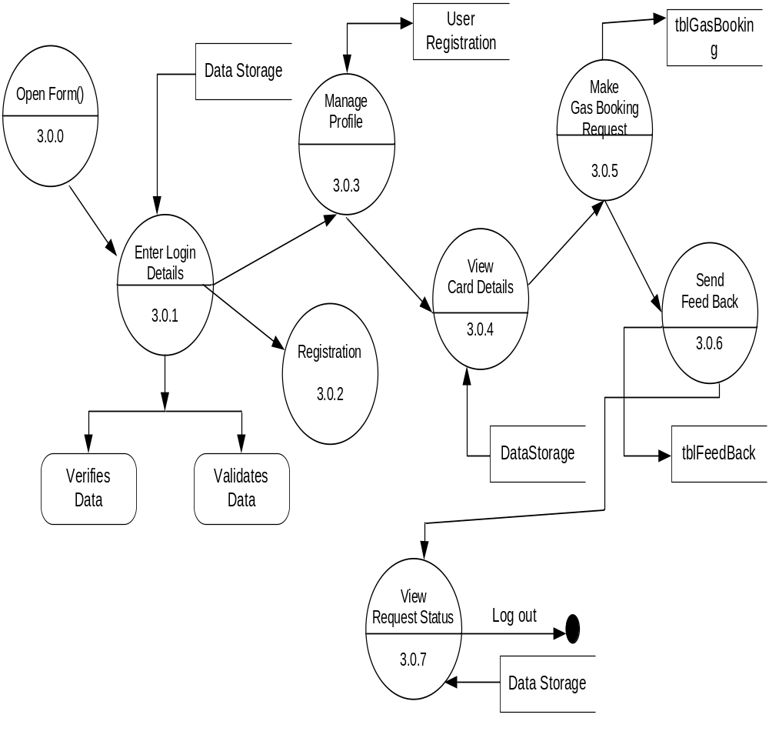

2nd Level DFD
